ITUE203: WEB DEVELOPMENT FRAMEWORKS 25CS106– Yana


Faculty of Technology and Engineering

Chandubhai S. Patel Institute of Technology (CSPIT) Department of Computer Science & Engineering

Laboratory manual
Academic Year | : | 2026-27 | Semester | : | 3rd

Practical - 08

PROBLEM STATEMENT :
Design the database for StudentHub with students, events and
registrations. Create PHP database connection using MYSQL statements.
OBJECTIVE:
To design and implement a MySQL database for the StudentHub web application containing students, events, and registrations tables. Establish a PHP database connection and execute MySQL queries to create, retrieve, and manage data efficiently.

OUTPUT:
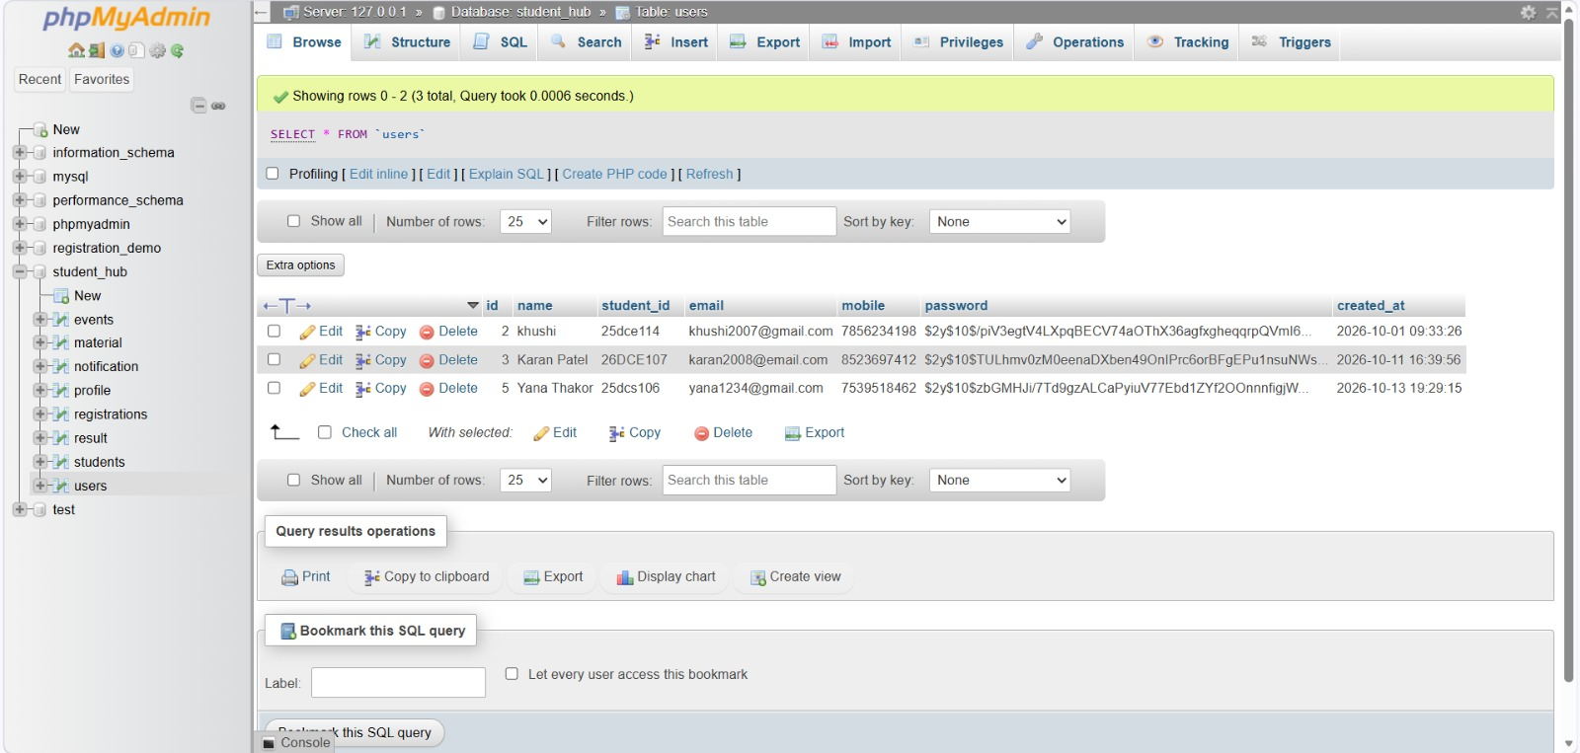

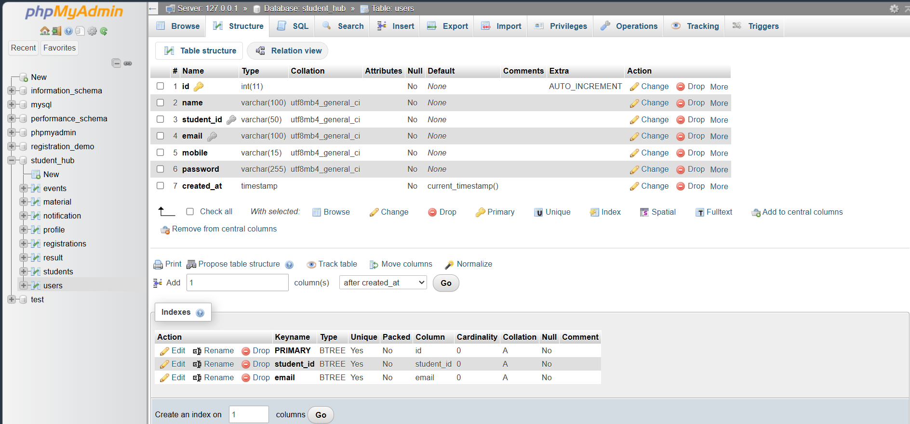

LEARNING OUTCOME:
Students will be able to design a relational database, create tables with appropriate primary and foreign keys, establish a database connection using PHP and MySQL, and execute SQL queries to manage student details, event information, and registrations.

